Notes on Encoding the problem for IIVP:

Summary:

Many slabs joined together

## Composite Slabs lowan

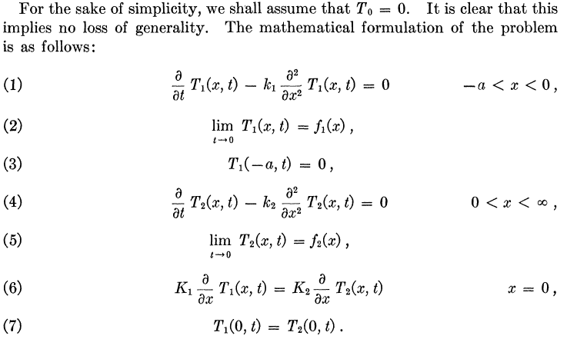

## Chapter 3 Interface problem (ALSO has linear algebra)

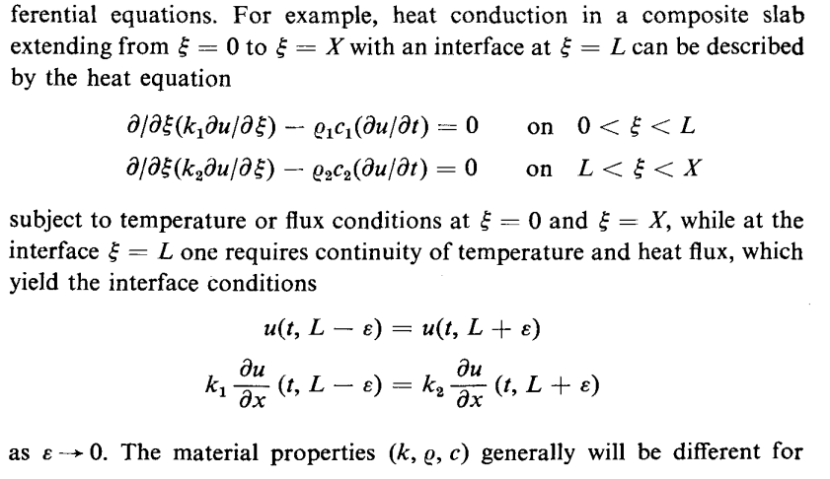

## Conduction of Heat in Solids

Composite problems

Not much detail

## Heat conduction Textbook

Moving interface problem

Need to consider?

## Heat equation on a network

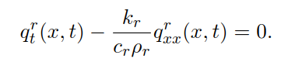

Scales the x?

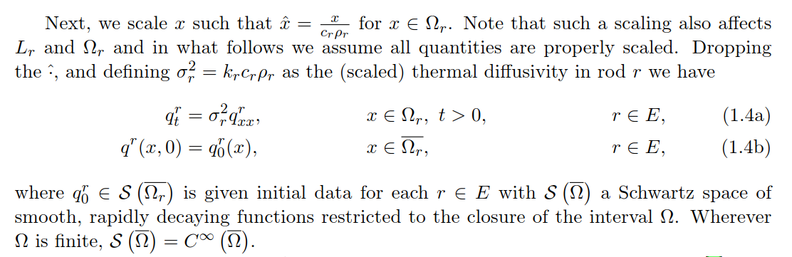

Assumes perfect thermal contact

Conditions

Temperature is the same on the left as on the right

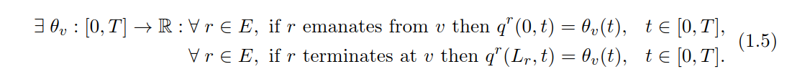

The first derivative is also the same on the left as on the right

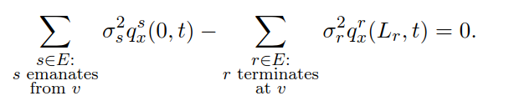

For vertexes with only one edge (so at the ends of the network), we have the conditions

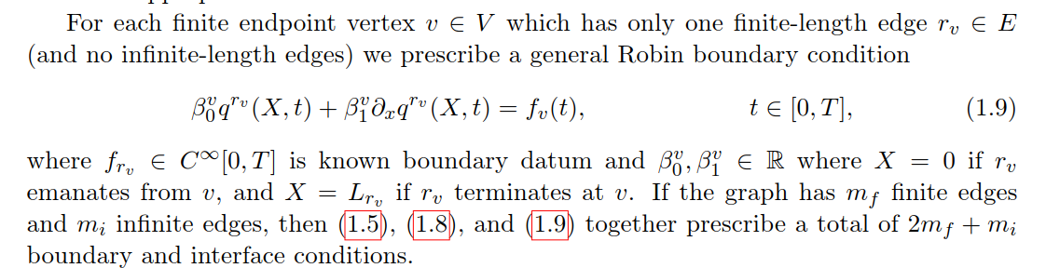

Total 2mf + mi conditions

Also, the interface and boundary conditions have to be compatible with initial conditions

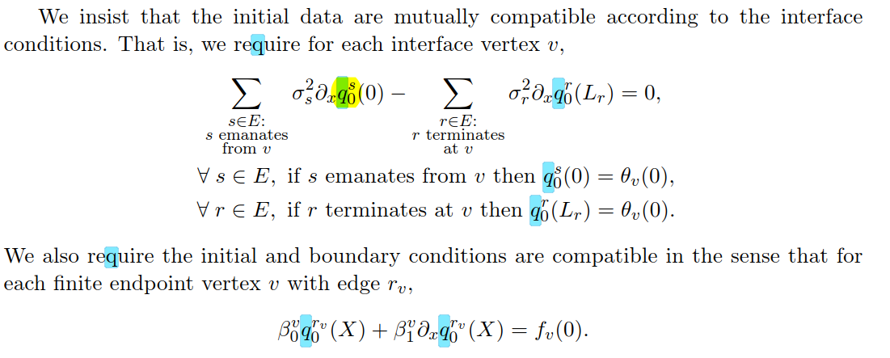

## Initial to interface Maps for the Heat equation in Composite

Newest paper?

Initial to interface map

Also assumes continuity

Considers infinite domain with finite interfaces

Also finite domain with finite interfaces

## Interface Problems for Dispersive equations

Dispersive equations, like the Schrodinger equation

Deals more with waves than heat

Still has similar conditions to the perfect thermal contact condition

But lets not pay too much attention to this…

## Multilayer diﬀusion in a composite medium with imperfect contact

Considers imperfect contact where instead of

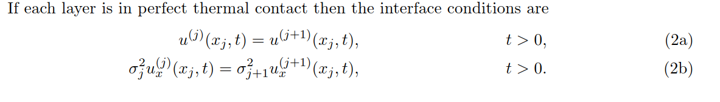

We have

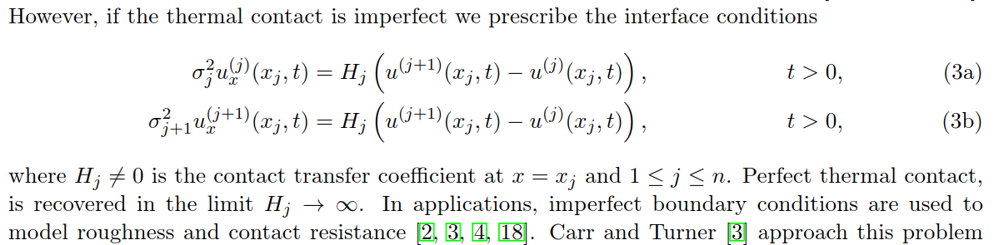

## Non-steady state heat conduction in composite walls

One of the more fundamental papers

Does not really generalize (has two and three domains only)

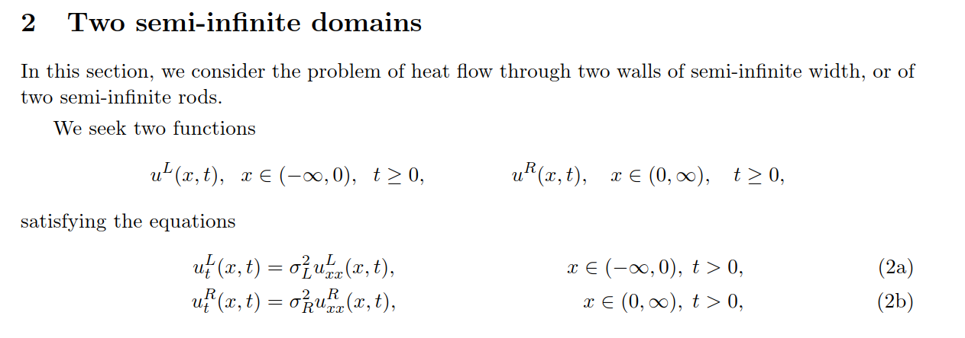

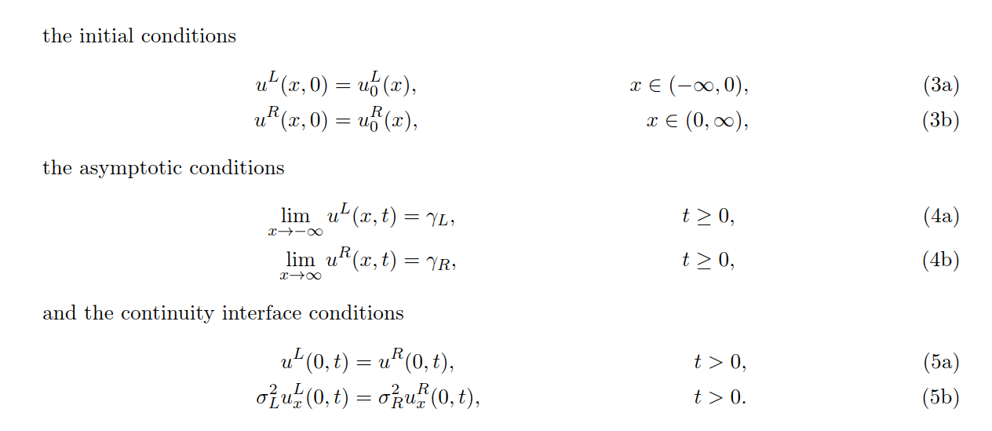

Has asymptotic conditions, which we can remove?

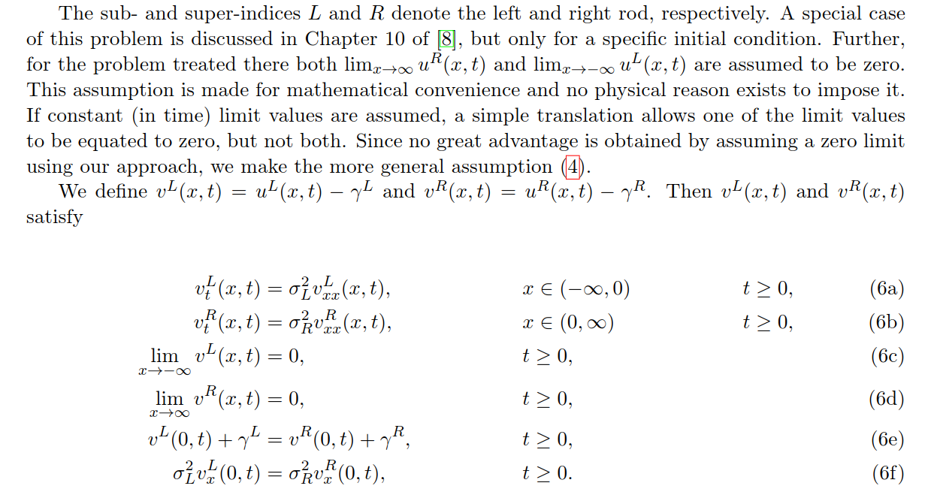

For finite walls:

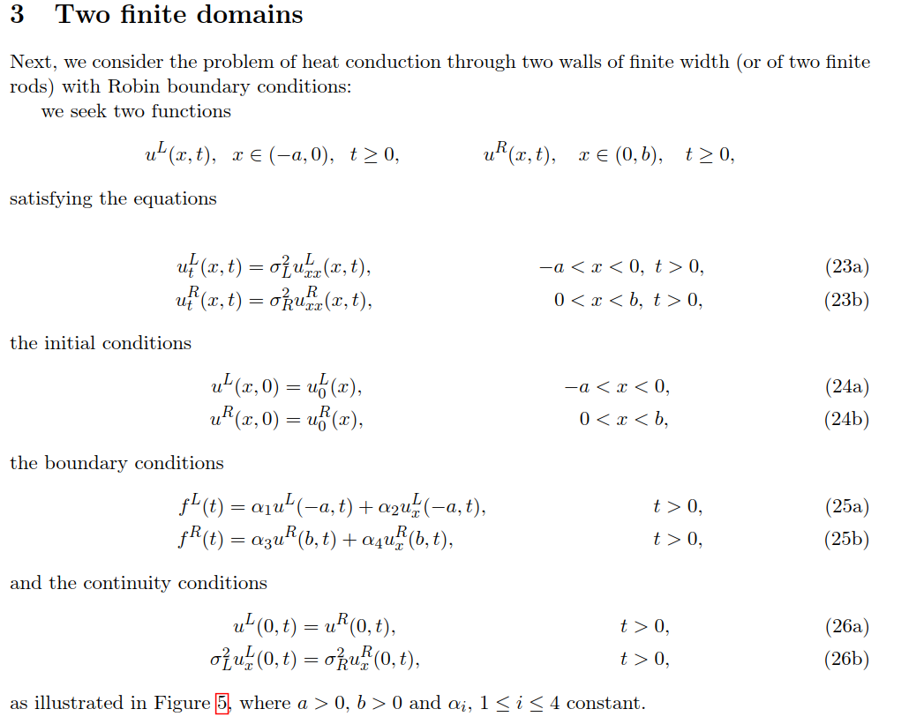

Robin conditions prescribe both Neumann and Dirichlet

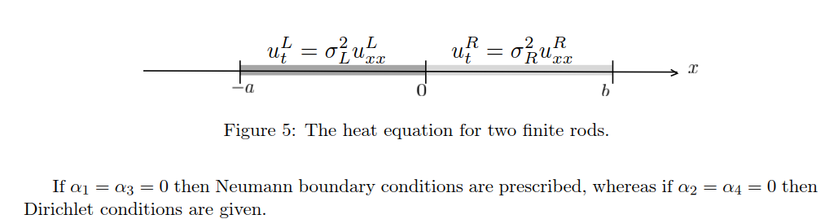

Infinite Domain with 3 layers

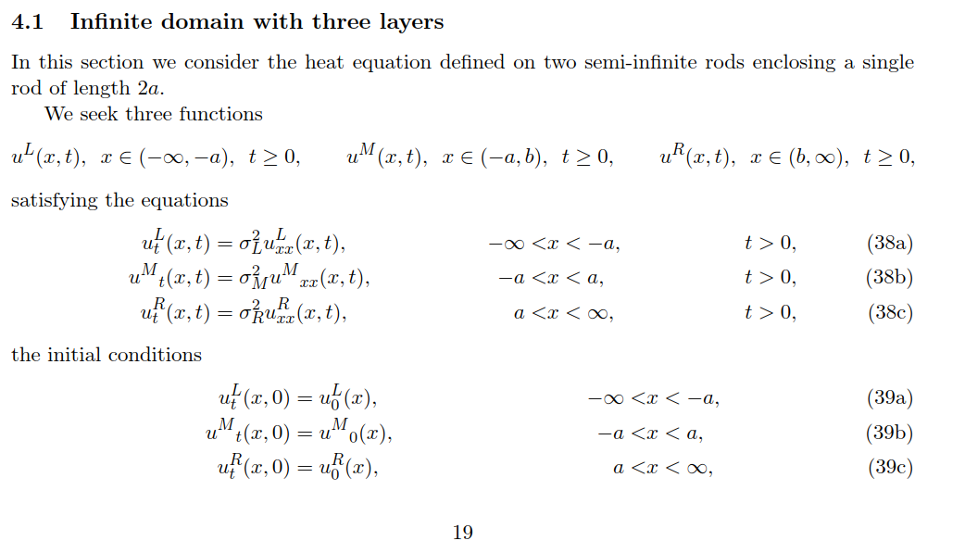

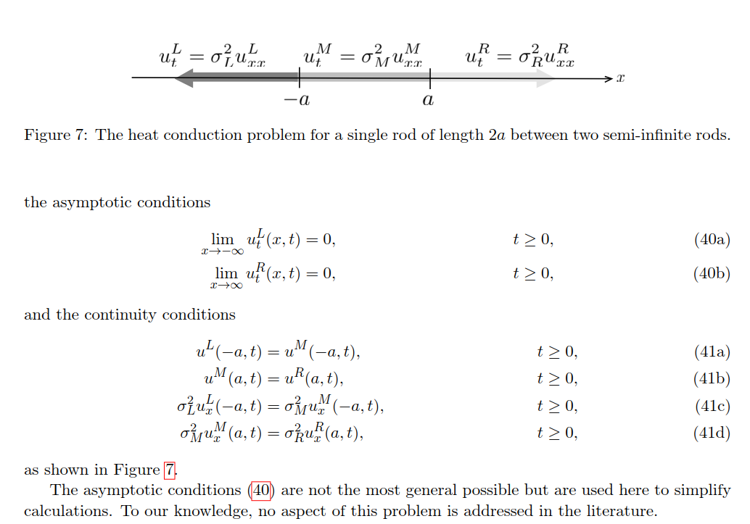

Finite domain with 3 layers

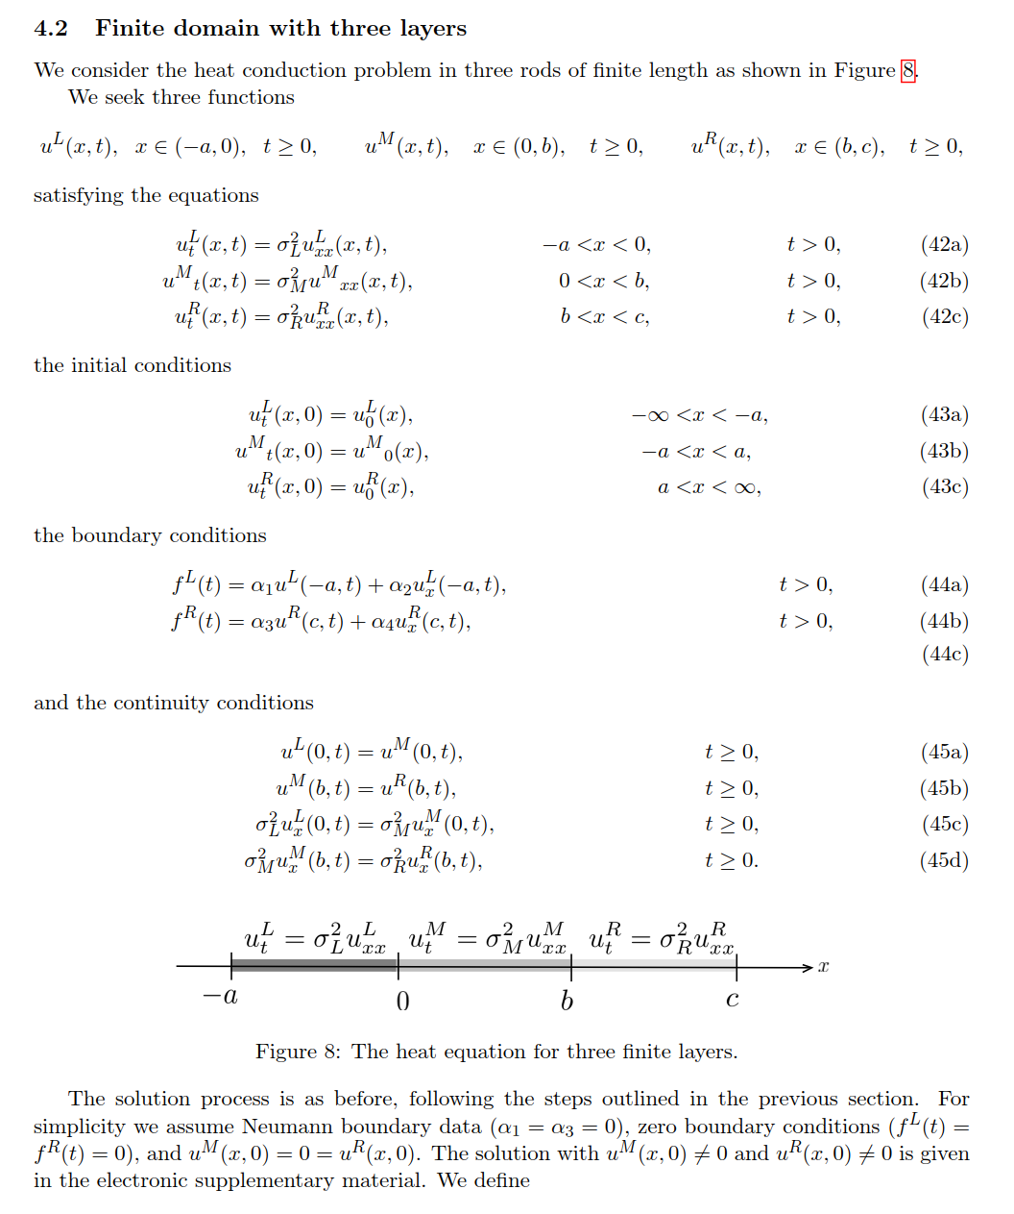

## On the Problem of Temperatures in a Non-Homogeneous Bar with Discontinuous Initial Temperatures Churchill

Different problem

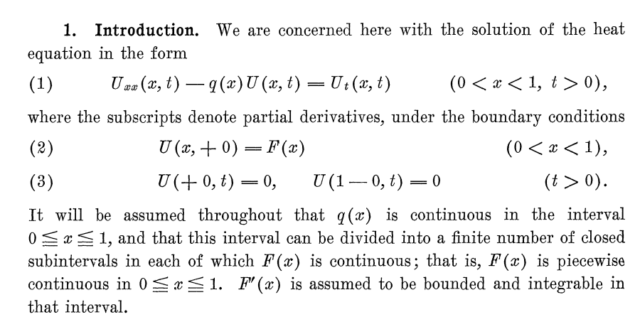

## TEMPERATURE DISTRIBUTION IN A SLAB OF TWO LAYERS Churchill

Classical way to solve the problem assuming:

Two slabs, finite thickness, left limit is 0 and right limit is c, perfect thermal contact

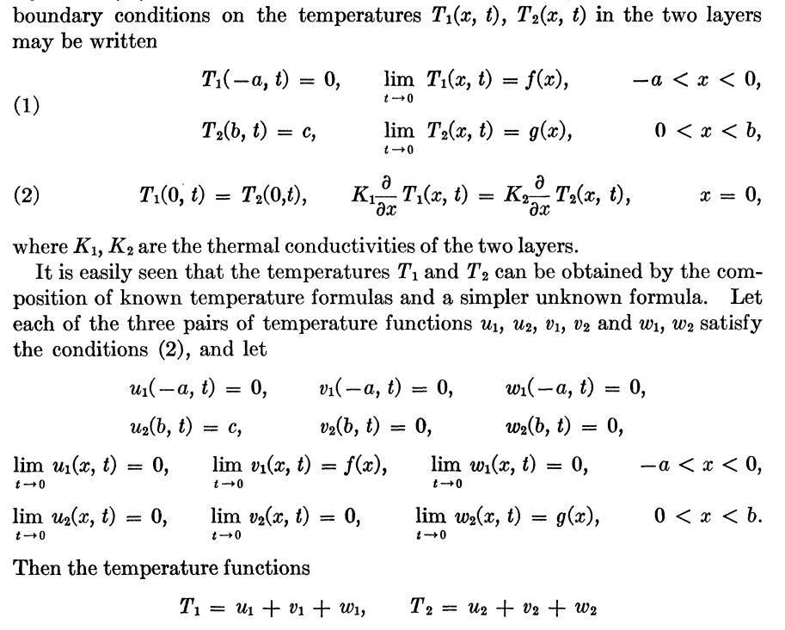

## The Linear KdV Equation with an Interface

Extend methods to higher order than two.

